**DSO 510: Business Analytics Homework 1 – Falak Jain (M 18:30 – 21:30)**

**Q1.**

* Yes, the online delivery option negatively impacts in store sales
* The total in-store sales for stores with the online delivery option declined in 2016

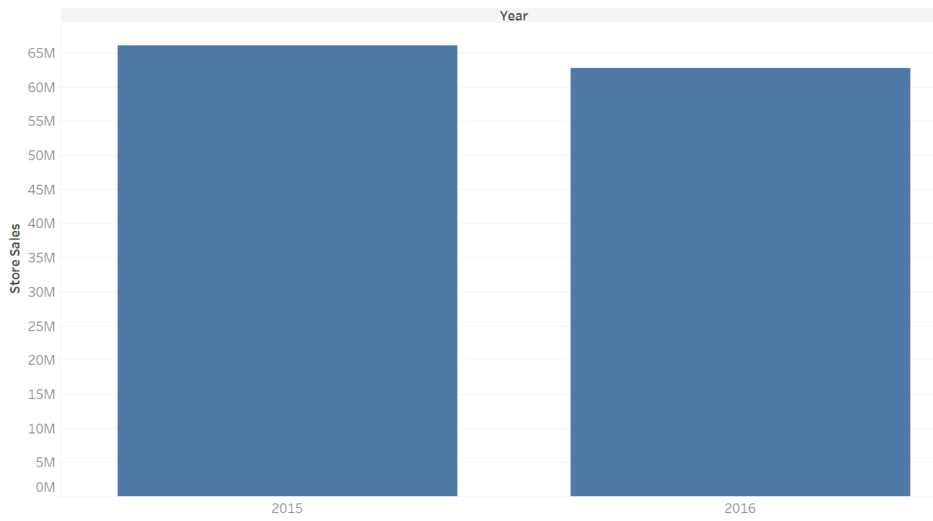

* While the total in-store sales for stores without the online delivery option increased in 2016

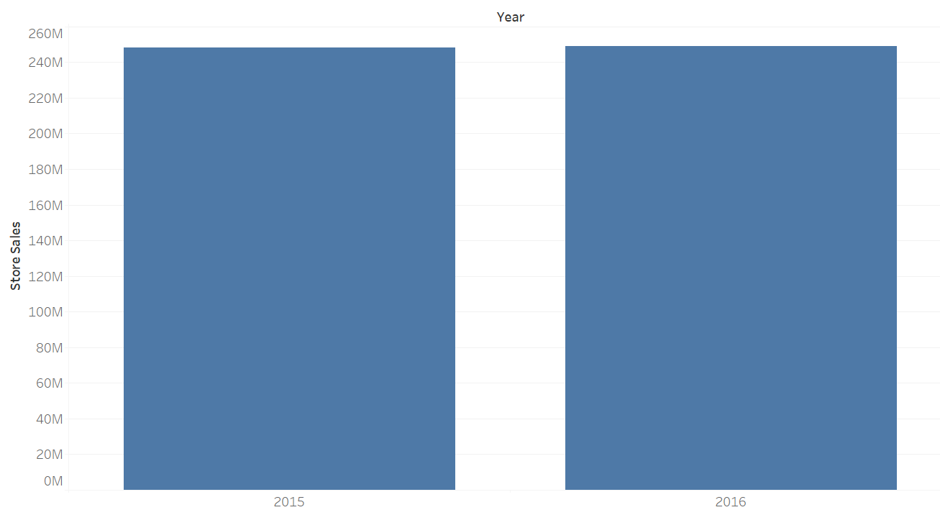

* Therefore, as we can see, the total in-store sales declined just for the stores with the online delivery option while they increased for the stores without the online delivery option. This indicates that this decline was not just due to lower grocery store demand in California in 2016.

**Q2.**

* Online delivery enabled stores without a pharmacy experienced a decline of 7.6% in their annual sales between 2015 and 2016. Whereas, similar stores with a pharmacy witnessed a decline of just 1% in their annual sales between 2015 and 2016.
* 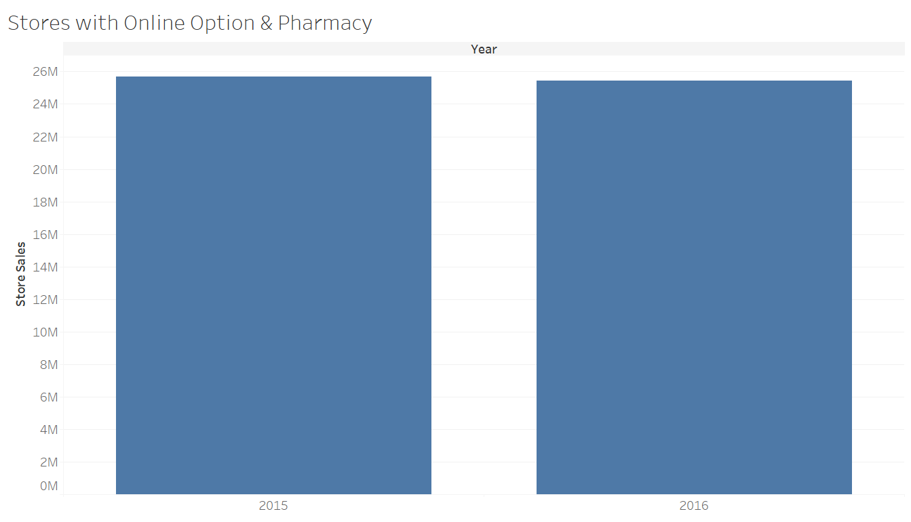
* 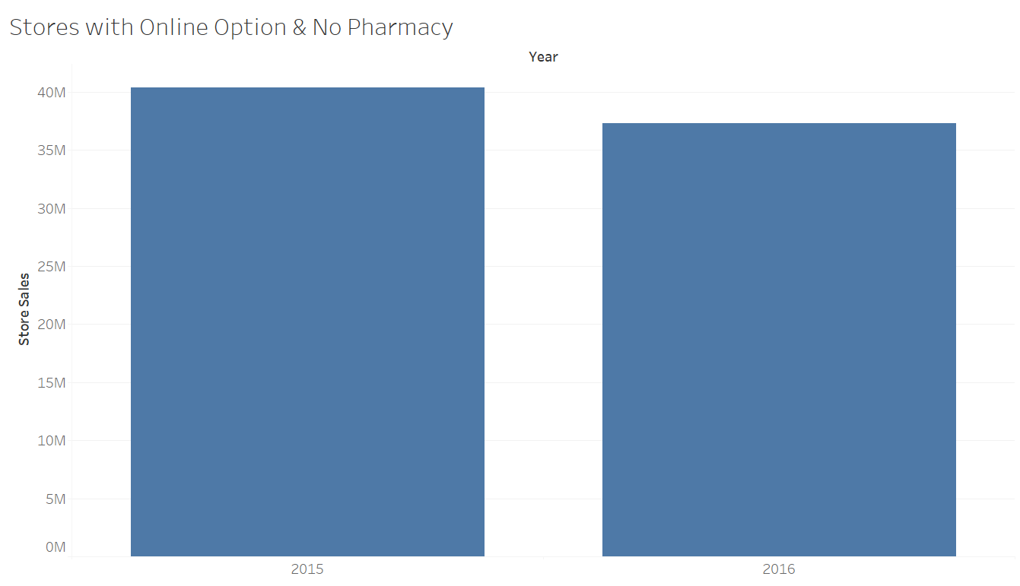
* A probable reason for this could be that customers are more likely to buy medicines in person as they require prescriptions which may not be easy to provide through the online delivery option. Whereas, in the case of stores with just groceries and no pharmacy, customers can easily decide their grocery requirements and place the order online without any document verification required which makes the process hassle-free.

**Q3.**

* Online delivery enabled stores situated in zip codes with high income experienced a decline of 5.4% in their annual sales between 2015 and 2016. Whereas, similar stores in low income zip codes witnessed a decline of just 1.8% in their annual sales between 2015 and 2016.
* 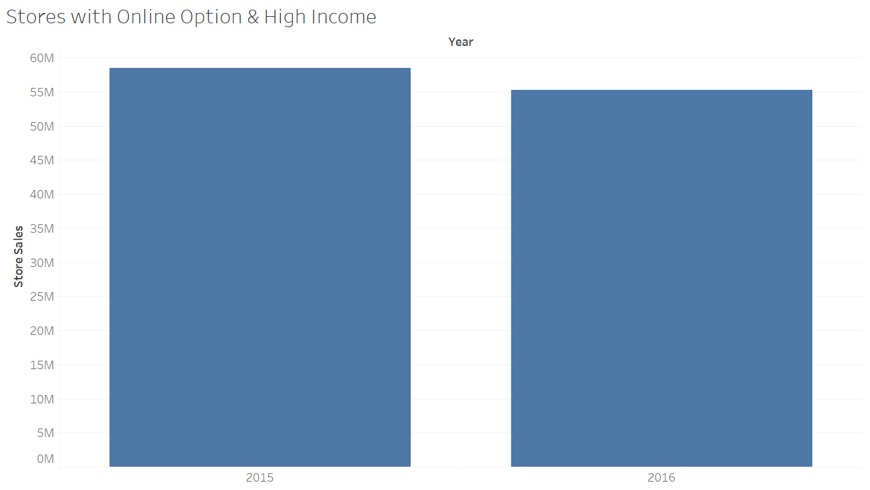
* 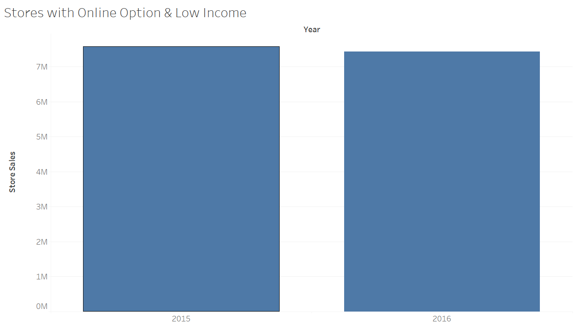
* The higher decline in sales in stores located in high income zip codes could be due to the increased willingness of higher income individuals to pay the additional charge for the third-party delivery company.

**Q4.**

* Online delivery enabled stores situated in zip codes with high population experienced a decline of 5.3% in their annual sales between 2015 and 2016. Whereas, similar stores in low population zip codes witnessed a decline of 5.0% in their annual sales between 2015 and 2016. When comparing on the basis of low and high population zip codes, stores with an online delivery option have a similar decline in sales.
* 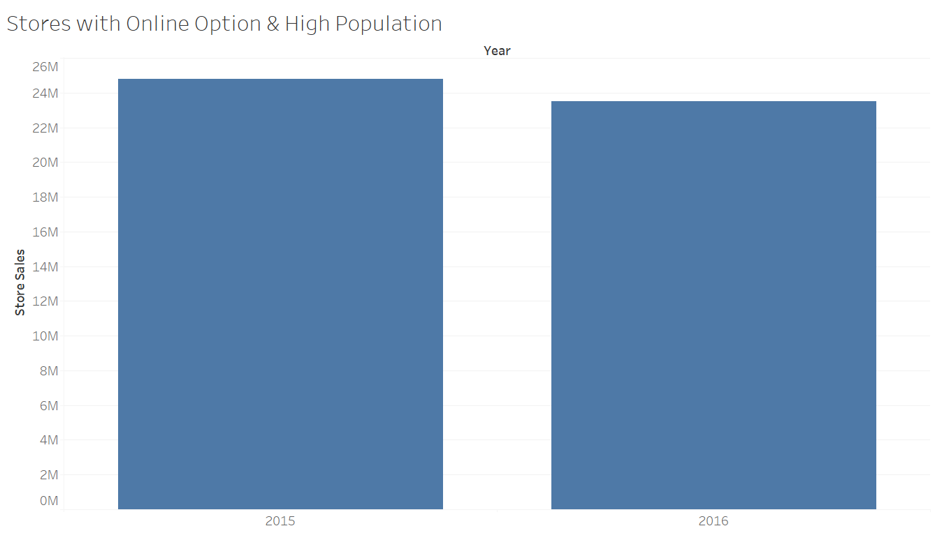
* 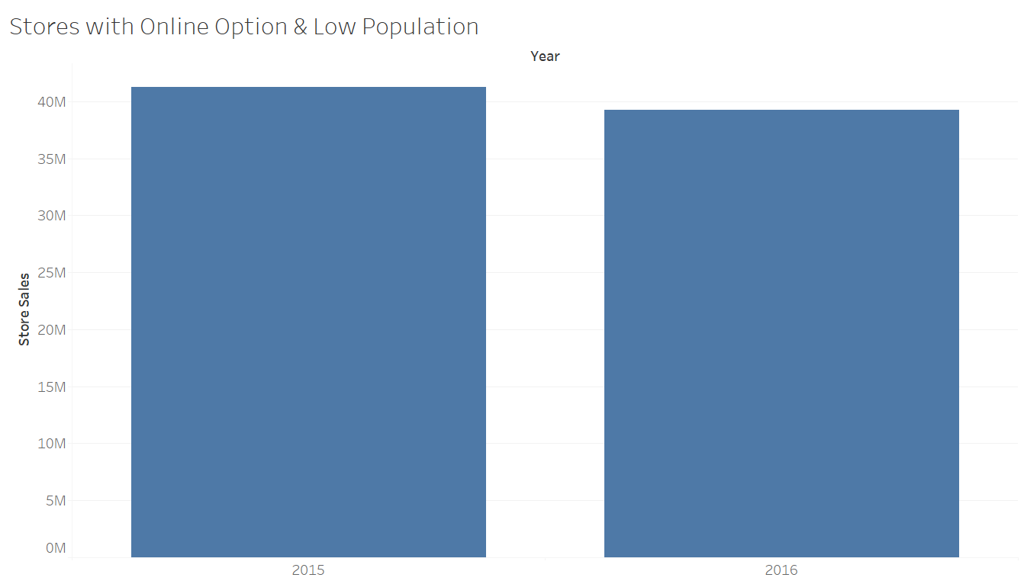
* There is not a large difference between the decline in sales in the two categories.

**Q5.**

* 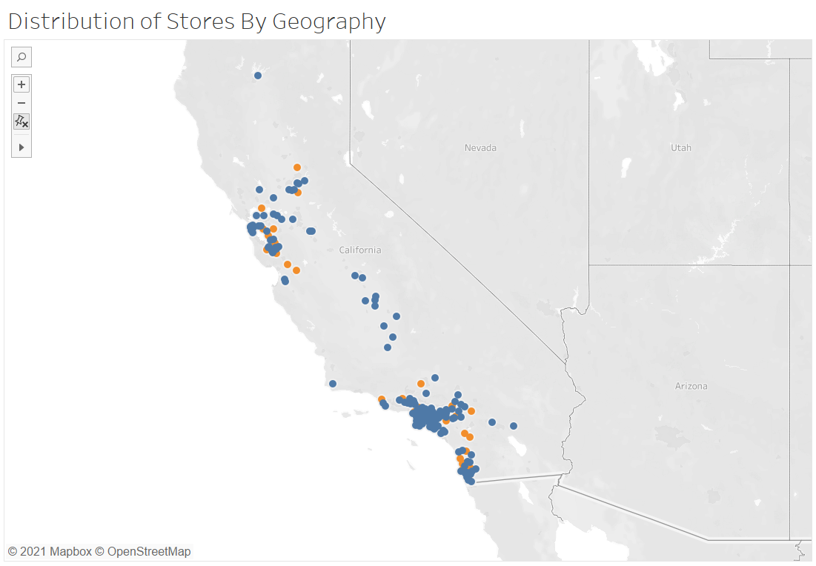
* Stores chosen for the online delivery method seem to be located primarily in northern and southern California.
* 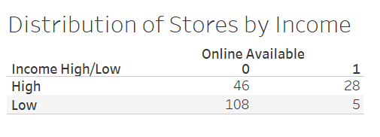
* 38% of high-income zip codes are selected to offer the online delivery option while just 5% of low-income zip codes are selected to offer the online delivery option. Therefore, selection of stores for online delivery is not random on the basis of median income.
* 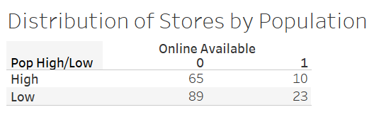
* 13% of high-population zip codes are selected to offer the online delivery option while 21% of low-population zip codes are selected to offer the online delivery option. Therefore, selection of stores for online delivery is not random on the basis of population.
* 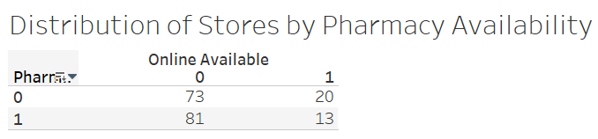
* 22% of stores without a pharmacy are selected for the online delivery option while 14% of stores with a pharmacy are selected for the online delivery option. Therefore, selection of stores for online delivery is not random on the basis of pharmacy availability.
* By selecting stores for online delivery options randomly, we will be able to ensure that the results are representative of the larger group and less likely to be subject to biases such as location, income, population or pharmacy availability. We will then be able to understand in which locations and location attributes do stores with online delivery options tend to benefit the business objective and where they prove to be a disadvantage to the same.

**Q6.**

* While we can see that the total online sales declined among stores with the online delivery option, we are not aware of the total sales that these stores received through the online option. Without this information, we will not be able to conclude the effectiveness of the online delivery option which is important before introducing it to all the stores.
* We are also not aware which specific items do customers prefer to order online and therefore stores will not be able to make sound stocking and inventory decisions without the online sales data when implementing the online option throughout all stores.
* Without online data, we will also be unable to project the revenue as well as the associated costs such as personnel and inventory.